**ECEN 214 - 302**

**Lab member: Alex Allahar**

**TA: Navid Naseh**

**Date lab performed: 06/16/22**

**Date report is due: 06/21/22**

1. **Procedure**

To begin the lab I started by measuring the voltage output from a 9V battery. After connecting the battery to the breadboard, I connected the AD2 to the breadboard. Once connected I measured the voltage output from the battery, and recorded this voltage value. Next, I placed a load resistor of 100 ohms between the battery terminals. Using the AD2 I found and recorded the new voltage value. I repeated this process for the following load resistor values: 1 kiloohm, 10 kiloohms, 100 kiloohms.

The second portion of the lab focused on a variable voltage source. Using a potentiometer for R1 and a fixed resistor for R2, I was able to create a voltage divider, with the 9V battery. I found the circuit’s voltage range by measuring voltage when the potentiometer was near 0 ohms and near 10 kiloohms. Using the AD2 to measure the voltage across the range, I then adjusted the potentiometer to get the voltage around 5V. Across the output terminals of the voltage divider I then placed a load resistor of 100 ohms. I repeated this process for the following load resistor values: 1 kiloohm, 10 kiloohms, 100 kiloohms. After finding and recording these values I adjusted the potentiometer to a value around 1.5V. Across the output terminals of the voltage divider I then placed a load resistor of 100 ohms. I repeated this process for the following load resistor values: 1 kiloohm, 10 kiloohms, 100 kiloohms. I recorded the measured voltage for their respective load resistor.

Changing the order of the potentiometer and fixed resistor, I created a similar voltage divider. With R1 being a fixed resistor and R2 being the potentiometer, I measured the new circuit’s voltage range with the 9V battery. I then did the same process shown in the voltage divider before. And recorded the difference load resistor voltage values at 5V and 1.5 V.

For the last part of the lab I created a voltage divider where both R1 and R2 was variable. To do so I used all three terminals of the potentiometer. Once the voltage divider was constructed I did the same process shown in the two voltage dividers before. And recorded the data shown in some of the data table below:

1. **Data Tables**

| 9V Battery | 9.006 V |
| --- | --- |
| Ohms | Voltage |
| 100 | 8.034 |
| 1000 | 8.704 |
| 10000 | 8.932 |
| 100000 | 9.105 |

**Figure 1: Task 1 Data**

|  | R2 Fixed | 2000 Ohms |  |
| --- | --- | --- | --- |
| R1 at 0 | 1.585 V | R1 at 10000 | 9.008 V |
| Pot at 5 V | 5.026 V | Pot at 1.5 V | 1.483 V |
| Ohms | Voltage | Ohms | Voltage |
| 100 | 0.533 | 100 | 0.092 |
| 1000 | 2.817 | 1000 | 0.598 |
| 10000 | 5.069 | 10000 | 1.498 |
| 100000 | 5.25 | 100000 | 1.515 |

**Figure 2: Task 2A Data**

|  | R1 Fixed | 8050 Ohms |  |
| --- | --- | --- | --- |
| R2 at 0 | 0.002 V | R2 at 10000 | 4.596 V |
| Pot at 5 V | 4.9 V | Pot at 1.5 V | 1.507 V |
| Ohms | Voltage | Ohms | Voltage |
| 100 | 0.108 | 100 | 0.062 |
| 1000 | 0.891 | 1000 | 0.432 |
| 10000 | 4.632 | 10000 | 1.438 |
| 100000 | 4.796 | 100000 | 1.48 |

**Figure 3: Task 2B Data**

|  | R1+R2 Variable |  |  |
| --- | --- | --- | --- |
| R1+R2 at 0 | 0.001 V | R1+R2 at 10000 | 9.001 V |
| Pot at 5 V | 5.001 V | Pot at 1.5 V | 1.506 V |
| Ohms | Voltage | Ohms | Voltage |
| 100 | 0.191 | 100 | 0.099 |
| 1000 | 1.425 | 1000 | 0.622 |
| 10000 | 4.004 | 10000 | 1.319 |
| 100000 | 4.881 | 100000 | 1.485 |

**Figure 4: Task 2C Data**

1. **Data Plots**

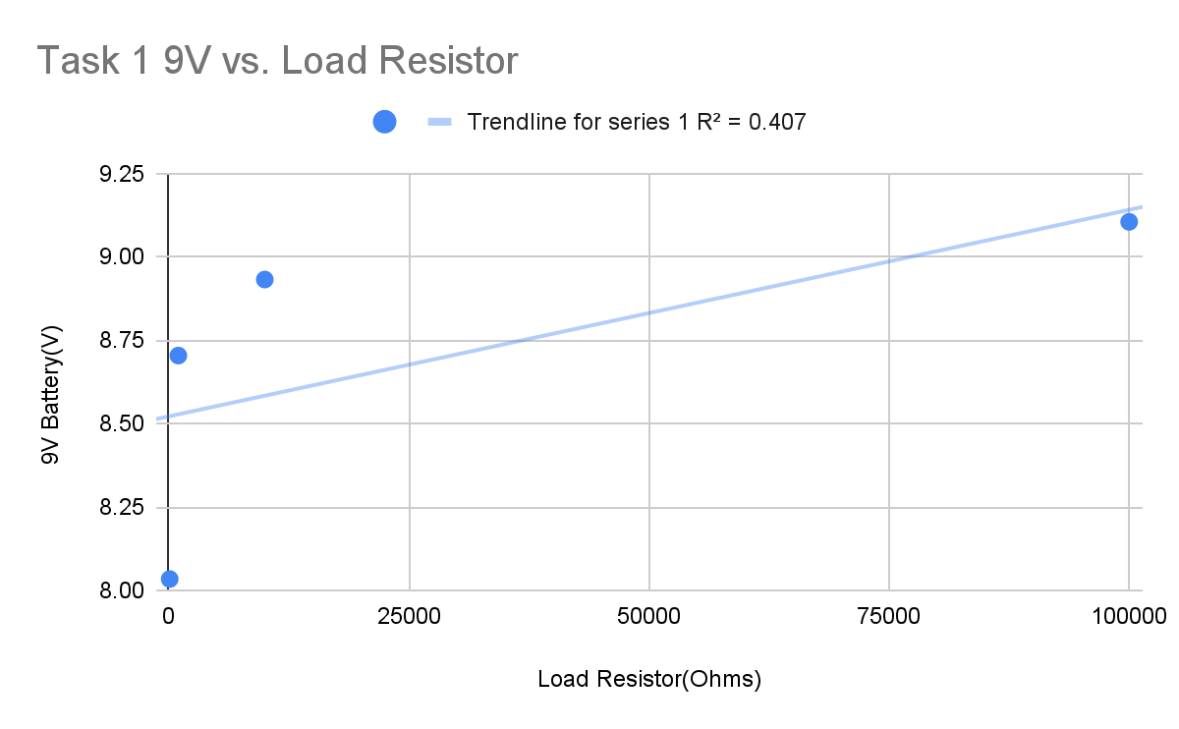

**Figure 5: Plot for Task 1**

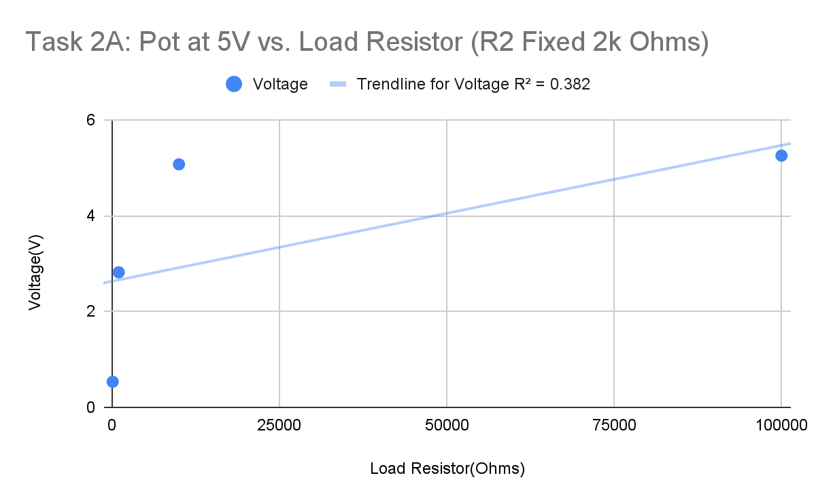**Figure 6: Plot at 5V for Task 2A**

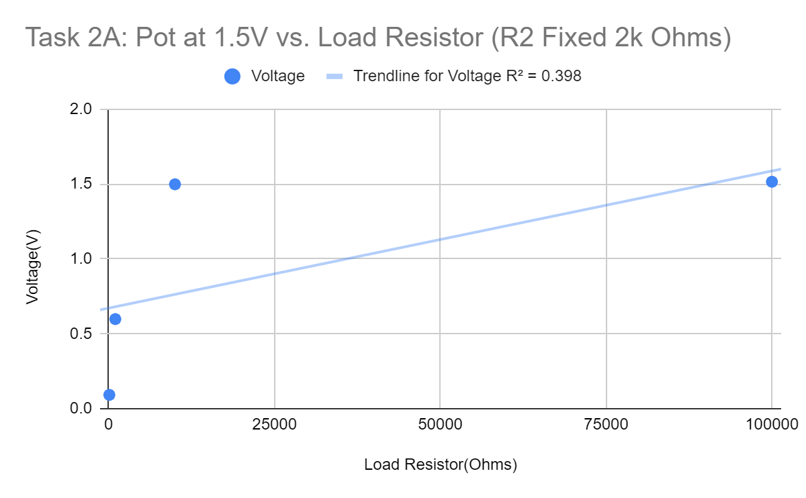**Figure 7: Plot at 1.5V for Task 2A**

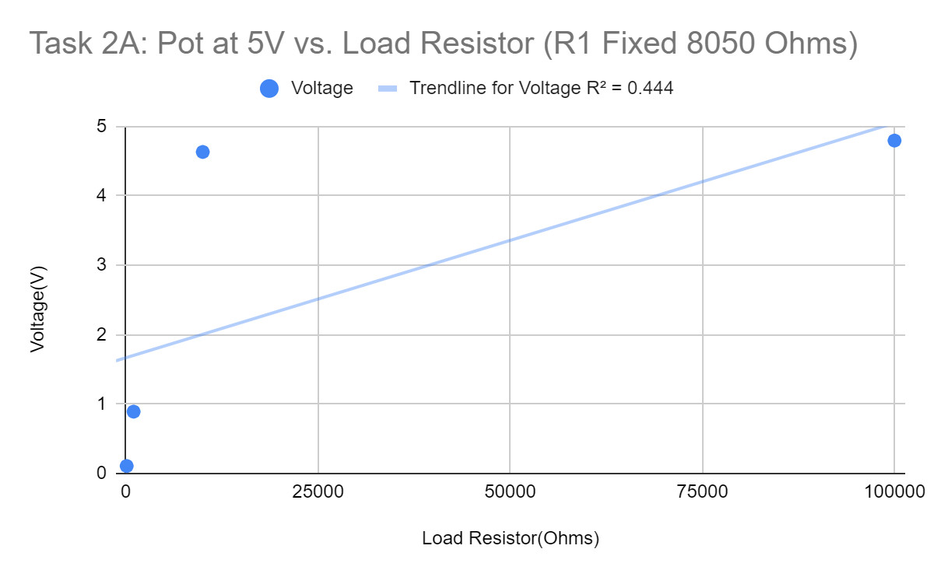

**Figure 8: Plot at 5V for Task 2B**

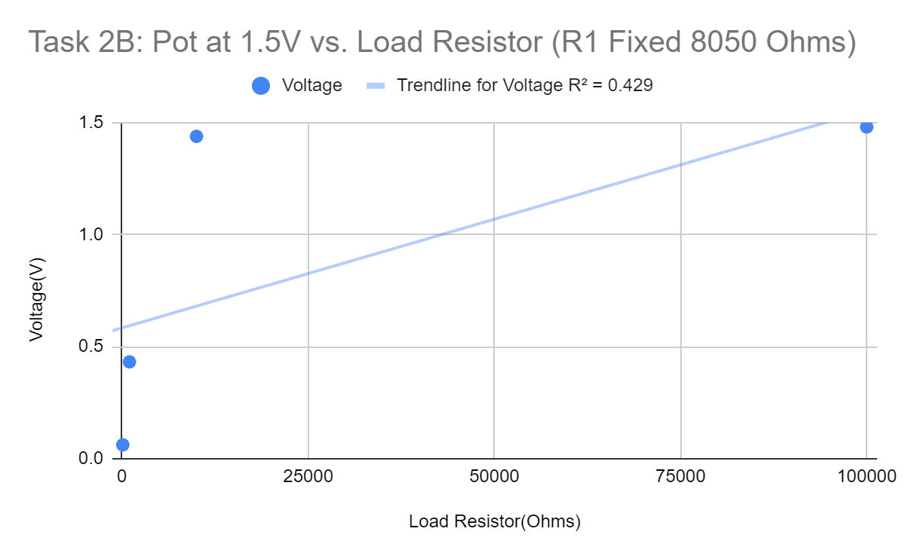

**Figure 9: Plot at 1.5V for Task 2B**

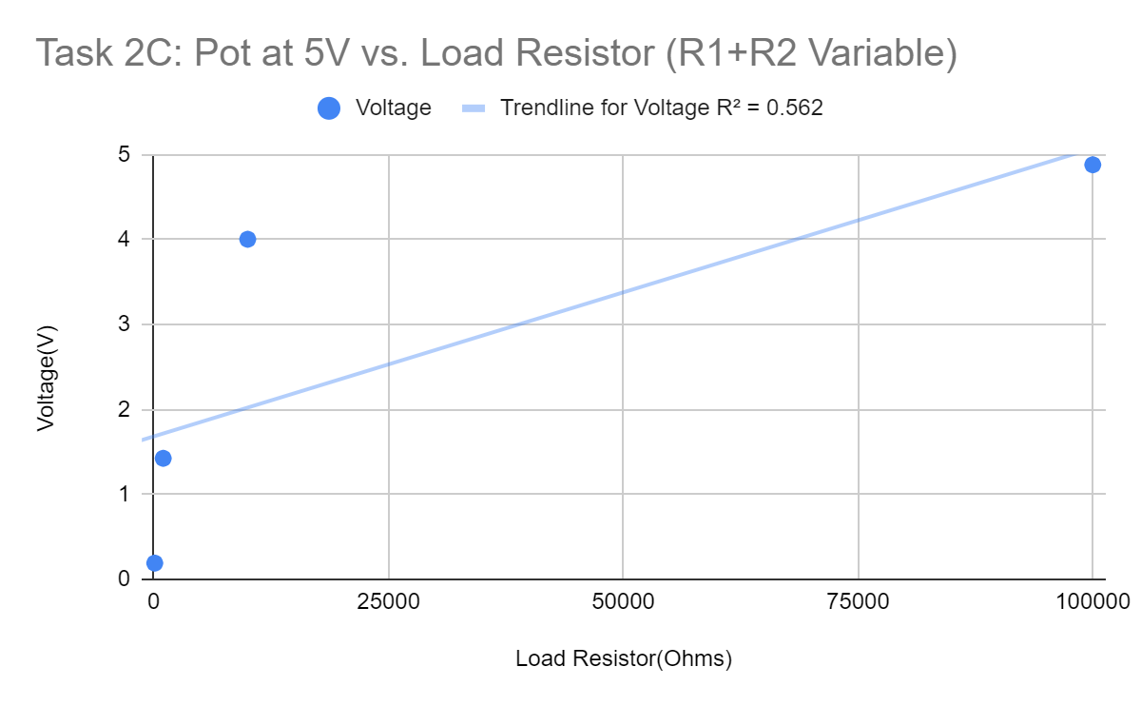

**Figure 10: Plot at 5V for Task 2C**

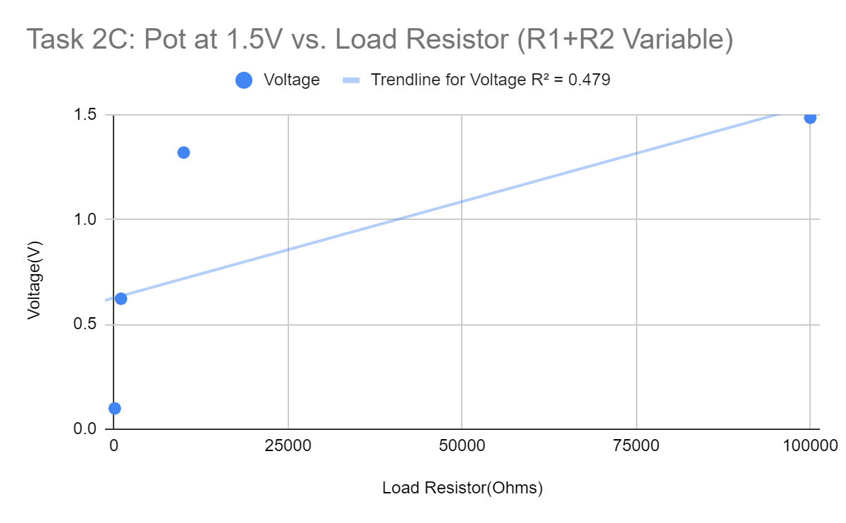

**Figure 11: Plot at 1.5V for Task 2C**

1. **Sample calculations**

${ V}_{2}=$ $V_{1}\frac{R_{2}}{R_{1}+R_{2}}$***Equation 1***

${ R}_{2}\left|\right|R_{L}=\frac{R_{2}R_{L}}{R_{2}+R_{L}}$***Equation 2***

Equation 1 was used during the prelab to determine what the voltage across R2 would be if the source voltage was V1.

Equation 2 is used during the discussion to find the equivalent resistance of R1 in parallel with R2. The equivalent resistance could then be used in Ohm’s law and the power formula to determine current and power delivered to the resistor, respectively.

1. **Discussion**
2. To find the sensitivity I can comparing the range of load resistances the circuit can tolerate while still producing the desired unloaded voltages to within 10%. I will focus on when the source is 5V unloaded, so my range of desired voltages is between 4.5 V and 5.5 V.

For when R1 varies and R2 is fixed at 2 kiloohms (configuration 1), one can adjust the unloaded voltage to be at 5V. Then, a load resistance of 10 kiloohms causes the voltage output to be 4.606 V, which is within the range. However, a load resistance of 1 kiloohm gives an output voltage of 2.659 V, which is outside the range.

When R1 is fixed at 8050 ohms and R2 varies (configuration 2) and the unloaded voltage is at 5V, a load resistance of 100 kiloohms gives a voltage output of 4.829 V, which is inside the range of accepted values. However, a load resistance of 10 kiloohms gives a voltage output of 3.493 V, which is will below the desired voltage range.

When both R1 and R2 are variable (yet add up to 10 kiloohms) (configuration 3), the unloaded voltage is 5V. In this configuration, a load resistance of 100 kiloohms will give a voltage output of 4.88044 V (inside the range), but a load resistance of 10 kiloohms will give a voltage output of 4.0042 V (outside the range).

By comparing the voltages that occur when the load resistance causes a voltage drop just below the range, one can see configuration 2 is the most sensitive to load resistance. This is because the first load resistance that causes the voltage to drop below 4.5 V is at 10 kiloohms, and it causes a voltage drop of 3.49271 V. This voltage drop value is much lower than the voltage drops produced by the other configurations at the same load resistance value, even though all configurations produce 5V when there is no load resistance.

On the other hand, configuration 1 is the least sensitive to load resistance. This is clear because the voltage output was still within the range of desired voltages when the load resistance was 10 kiloohms, which is not true for the other configurations.

1. When a load is connected, R1 and R2 are connected in parallel. When the variable resistance(potentiometer) is at its maximum, one can find that configuration 1 has an equivalent resistance of 1.67 kiloohms (with 2 kiloohms and 10 kiloohms in parallel). Configuration 2 has an equivalent resistance of 4.459 kiloohms (with 8050 ohms and 10 kiloohms in parallel). Configuration 3 has an equivalent resistance of 2.469 kiloohms (with 5.56 kiloohms and 4.44 kiloohms in parallel).

Using the assuming made earlier that configuration 2 was the most sensitive, and configuration 1 was the least sensitive. Thus, one can conclude that, to make circuits less sensitive to load resistance, one should decrease the equivalent resistance of the resistors in the voltage dividers. This can be done by decreasing the resistances of the resistors in the voltage dividers.

1. One can use the formula that power is equal to the square of voltage divided by resistance. Assume the 9V battery voltage is constant, and that the equivalent resistances of configurations 1, 2, and 3 are 1.67 kiloohms, 4.459 kiloohms, and 2.469 kiloohms, respectively. Based on the formula, larger parallel combinations of resistances will decrease the power.

Thus, to minimize power absorbed, one should seek a larger equivalent resistance from the parallel combination of resistors. This can be accomplished by increasing the values of R1 and R2.

1. **Conclusion**

During this lab, I learned how to use the AD2 and potentiometer. A special application of the potentiometer was in a variable voltage source that can produce a range of voltage values. However, I discovered that the voltage output of the voltage divider was sensitive to load resistance.

**Signed Data Pages**

* Attached in the submission